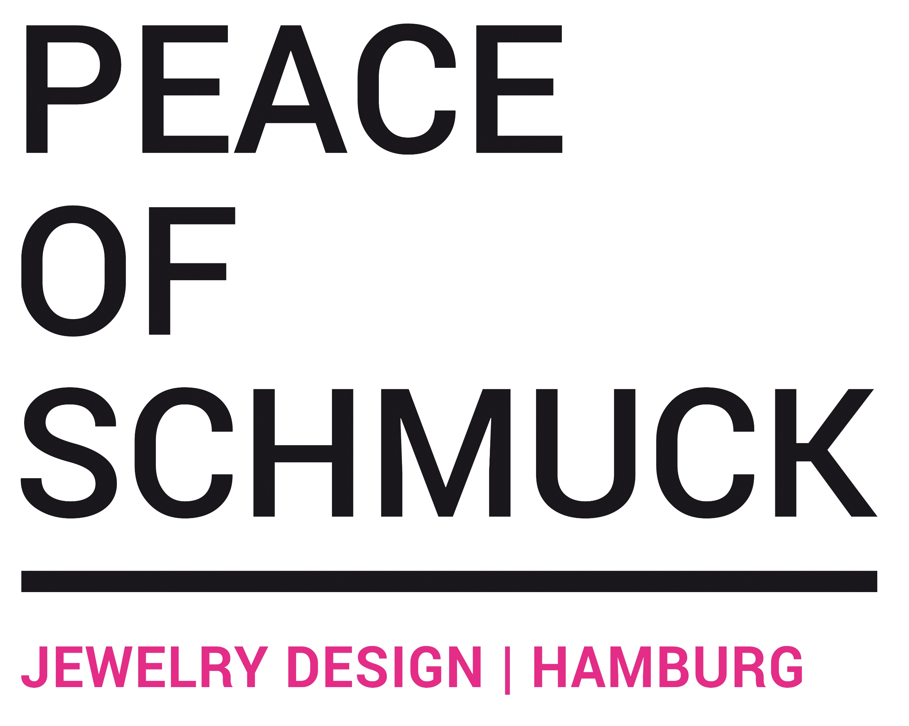

Press release: short & long.
Please contact us, if you need further information. mail@peaceofschmuck.com

short:
Contrary to today’s society tendencies, Peace of schmuck’s designs are all about one thing: embracing & celebrating individuality. The young, independent next big must-have label from Germany cherishes every imperfection of every single one-of-a-kind piece and already is an absolute insider tip. Their convincing philosophy reminds us: Be What You Are. Be Exceptional. Shop online and express yourself at: www.peaceofschmuck.com

long:
Peace of schmuck is a young, independent jewelry label from Germany.
Contrary to today’s society tendencies, Julia's designs are all about one thing: embracing and celebrating individuality & sustainability. Each one of the jewelry pieces explores this concept and shall keep you company for a long time. The designs are distinct and inspired by different cultures, experiences, and stories and are mainly manufactured from upcycled materials.
We LOVE how differently our designs are being worn, how every person adds their very unique style to the pieces and that they can help express them who they want to be.
Tell your story: Your jewelry. Your Style.
WHAT’S YOUR STORY?
Be What You Are. Be Exceptional.

